 | Ai + 1 | Ai | Bi+1 | Bi | M | I
Linha | X3 | X2 | X1 | X0
0 | 0 | 0 | 0 | 0 | 0 | 1
1 | 0 | 0 | 0 | 1 | 0 | 0
2 | 0 | 0 | 1 | 0 | 0 | 0
3 | 0 | 0 | 1 | 1 | 0 | 0
4 | 0 | 1 | 0 | 0 | 1 | 0
5 | 0 | 1 | 0 | 1 | 0 | 1
6 | 0 | 1 | 1 | 0 | 0 | 0
7 | 0 | 1 | 1 | 1 | 0 | 0
8 | 1 | 0 | 0 | 0 | 1 | 0
9 | 1 | 0 | 0 | 1 | 1 | 0
10 | 1 | 0 | 1 | 0 | 0 | 1
11 | 1 | 0 | 1 | 1 | 0 | 0
12 | 1 | 1 | 0 | 0 | 1 | 0
13 | 1 | 1 | 0 | 1 | 1 | 0
14 | 1 | 1 | 1 | 0 | 1 | 0
15 | 1 | 1 | 1 | 1 | 0 | 1

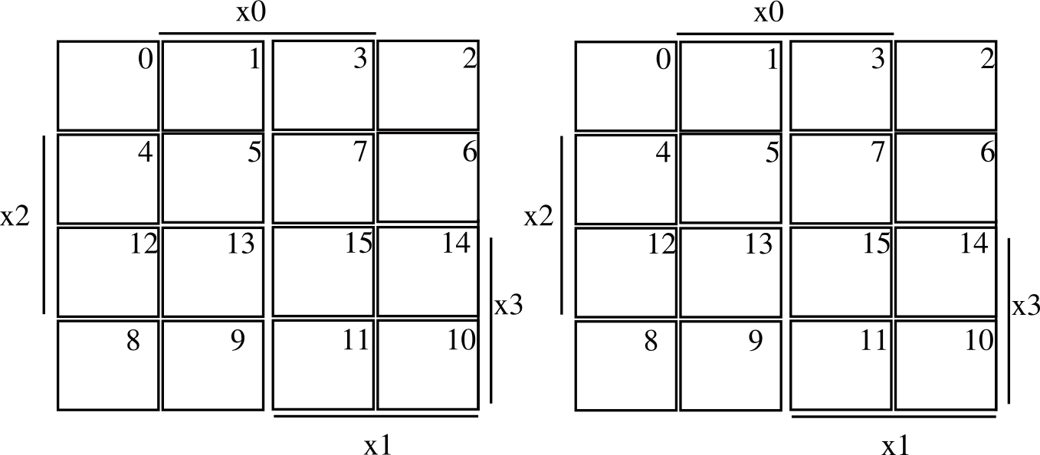

1

1
1

1
1
1
1

1
1
1

M = X3 ~X1 | X2 X3 ~X0 | X2 ~X0 ~X1 I = ~X0~X1~X2~X3 | X0 X2 ~X1 ~X3 |
X0 X1 X2 X3 | X1 X3 ~X0 ~X2

